COMPUTER NETWORK(LAB) Nallabothu Shailaja

192011163(CSE)

1.HUB

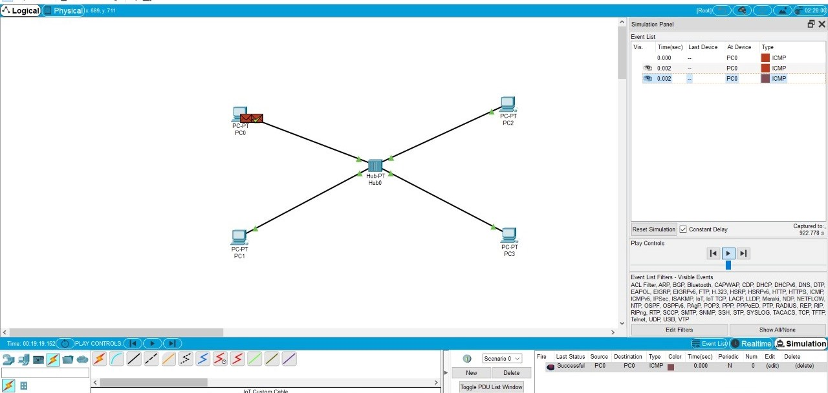

1B.SWICHES

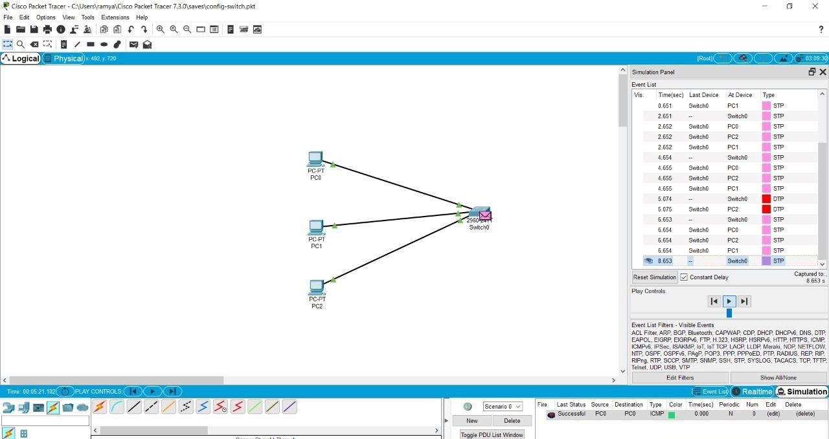

1C.EHERNET

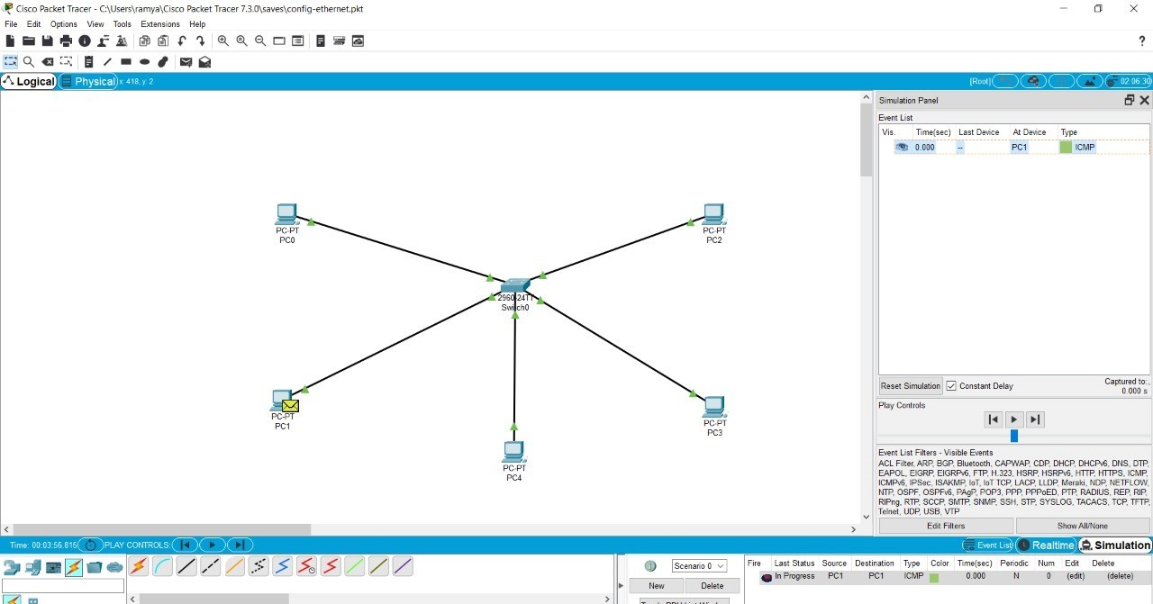

1D.BROADCOST



2A .STAR TOPOLOGY

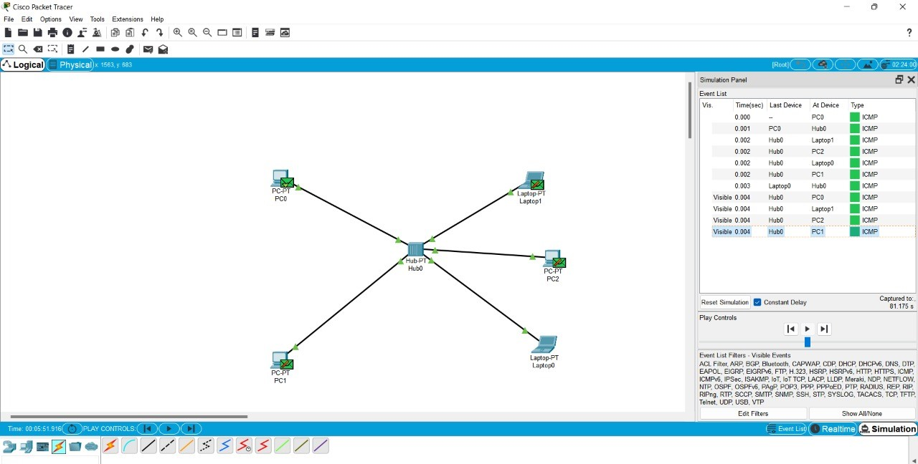

2.MESH

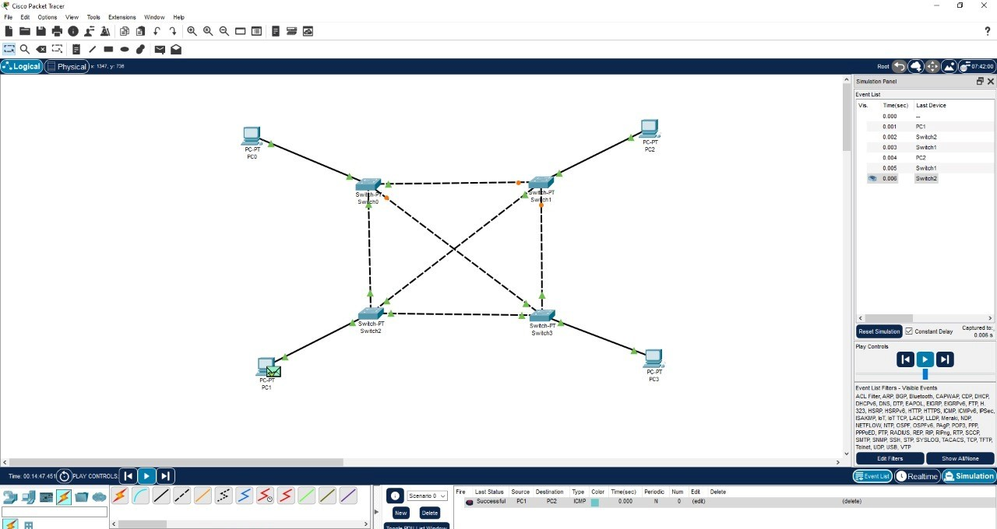

2B.TREE TOPOLOGY

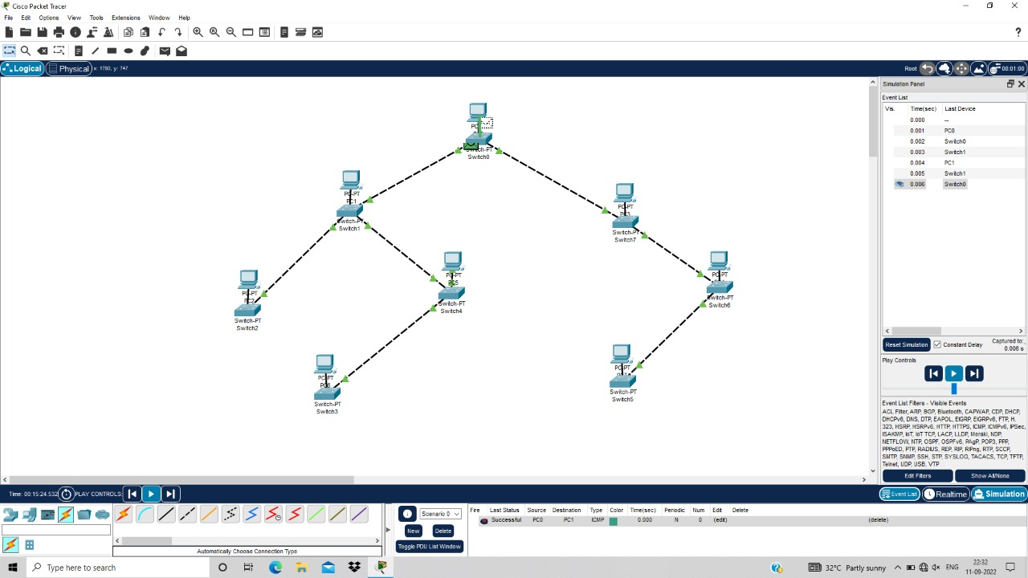

3.BUS

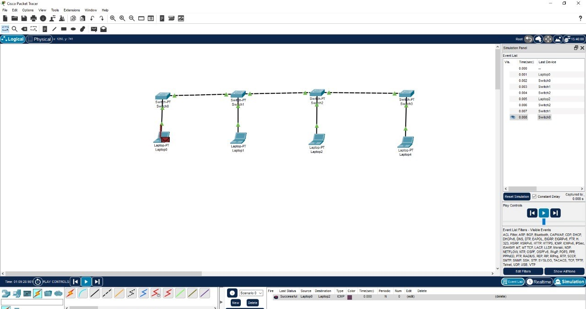

3B.RING TOPOLOGY

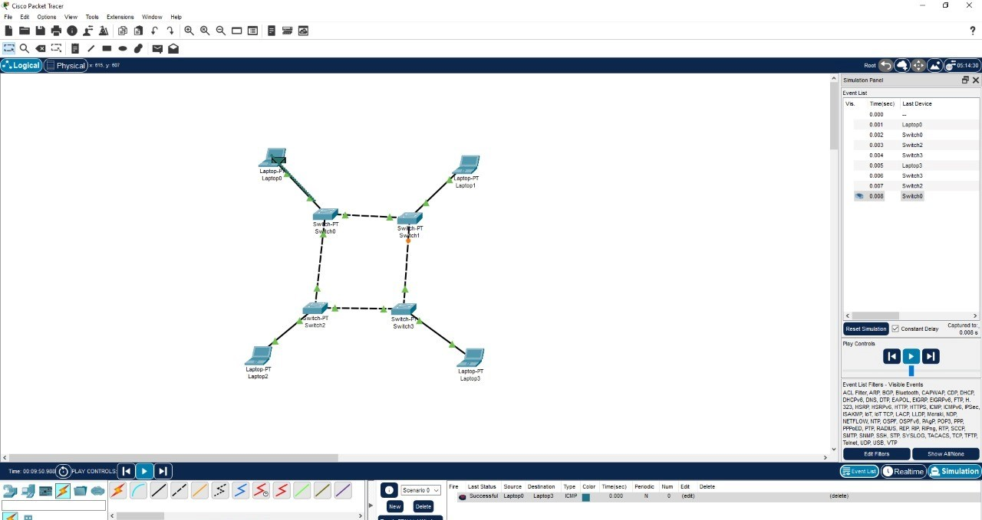

3D.HYBRID TOPOLOGY

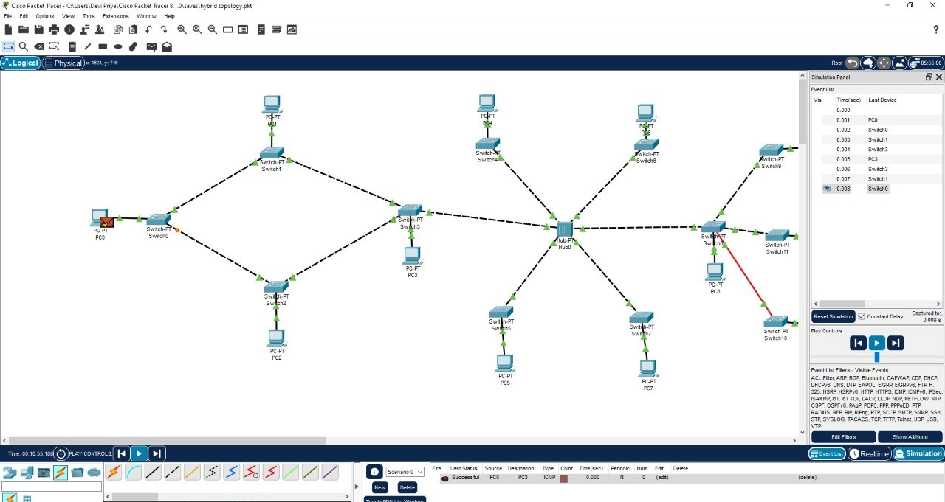

4.CSMA\CD

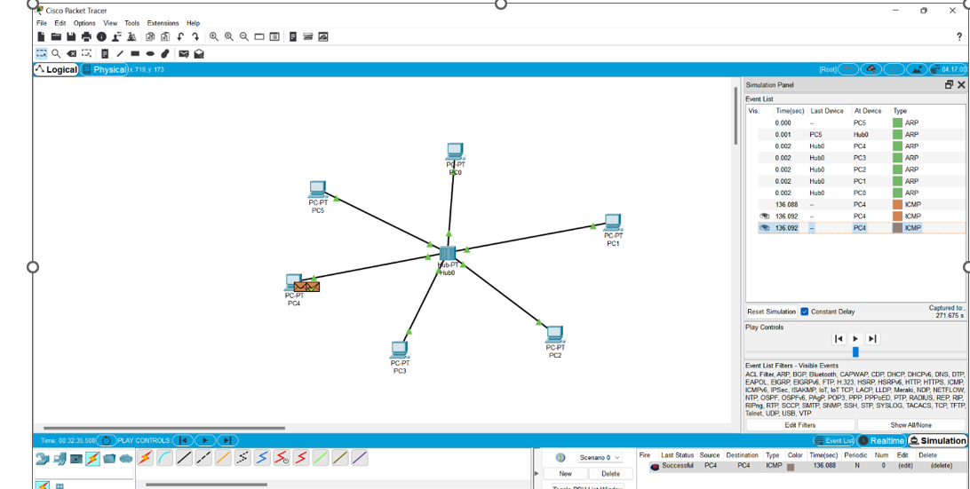

5.ARP

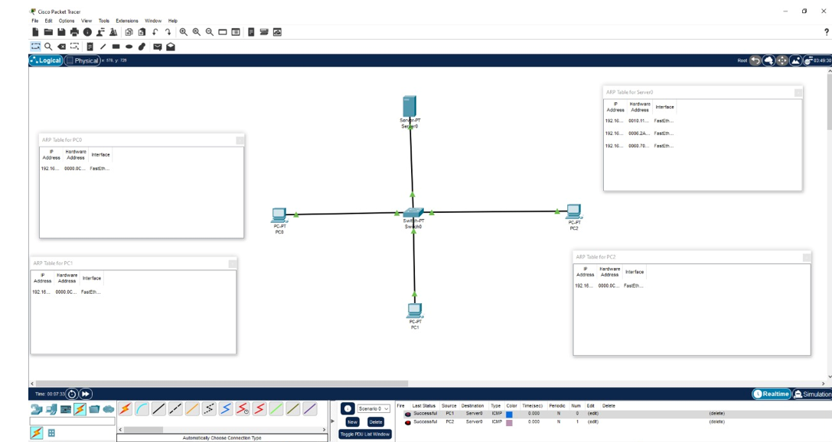

6.STATIC ROUTING

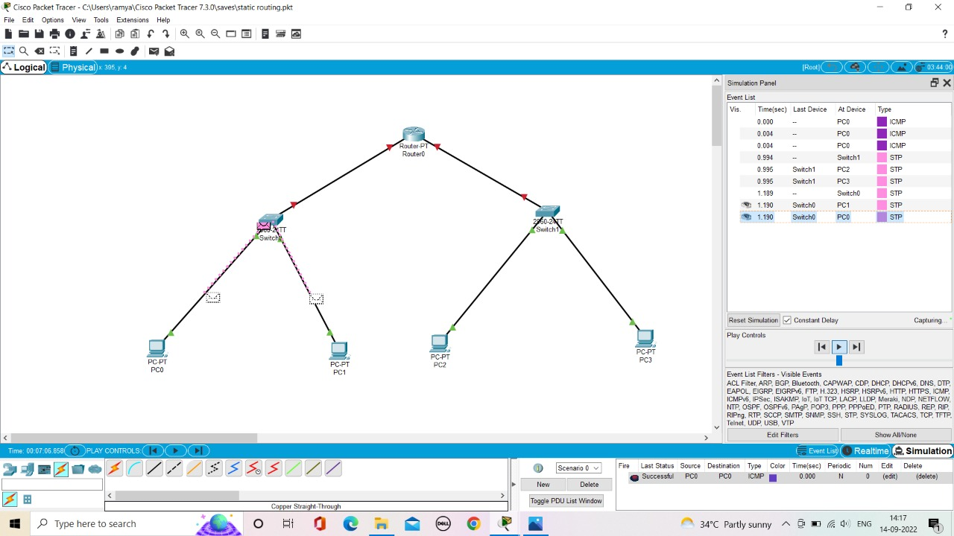

7.DYNAMIC ROUTING

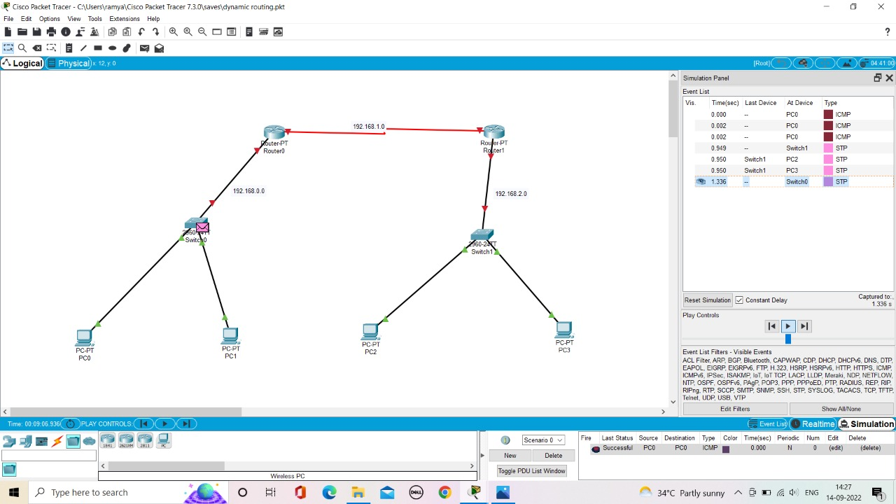

8.SUBNETTING

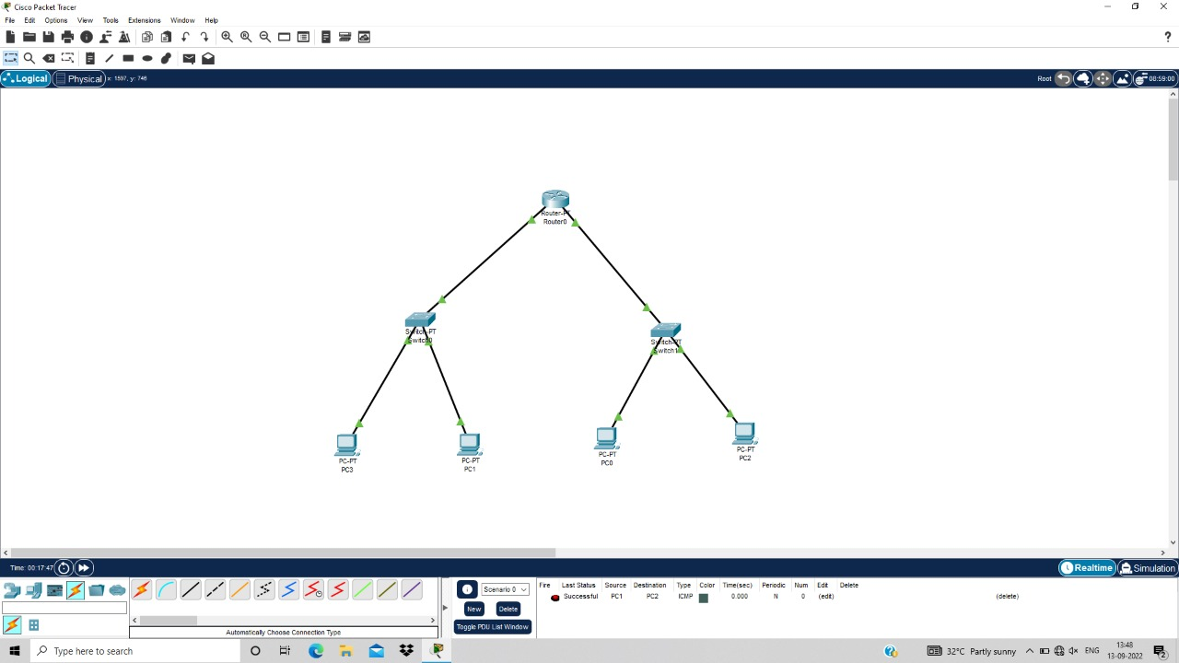

9.FUNCTIONALITIES OF TCP



FUNCTIONALITIES OF UDP

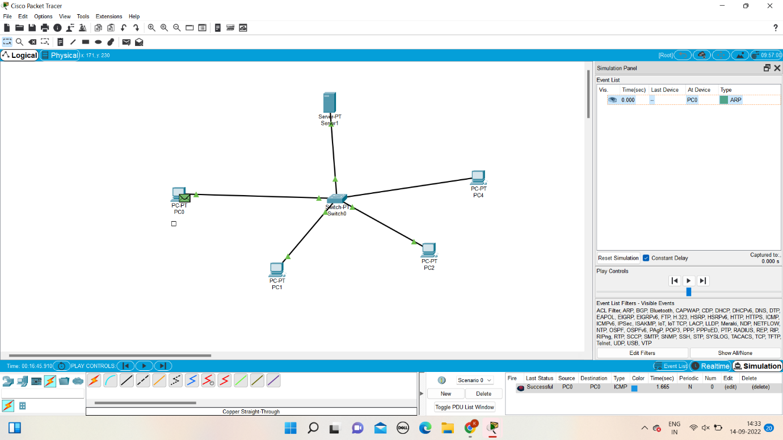

10.TCP EXPLORATION SOLUTION



UDP EXPLORATION SOLUTION



11. IOT BASED SMART HOME USING CISCO PACKET TRACER

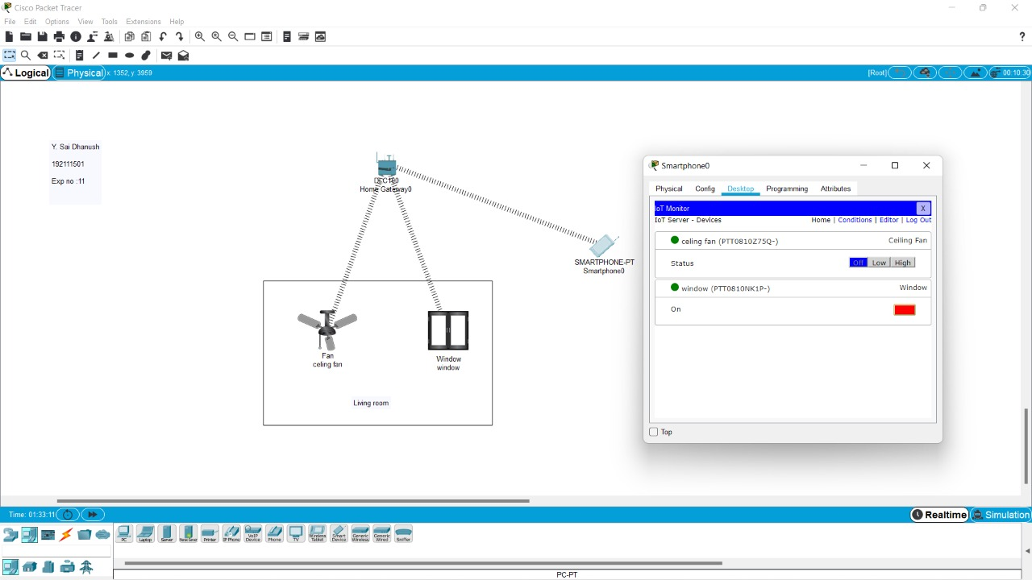

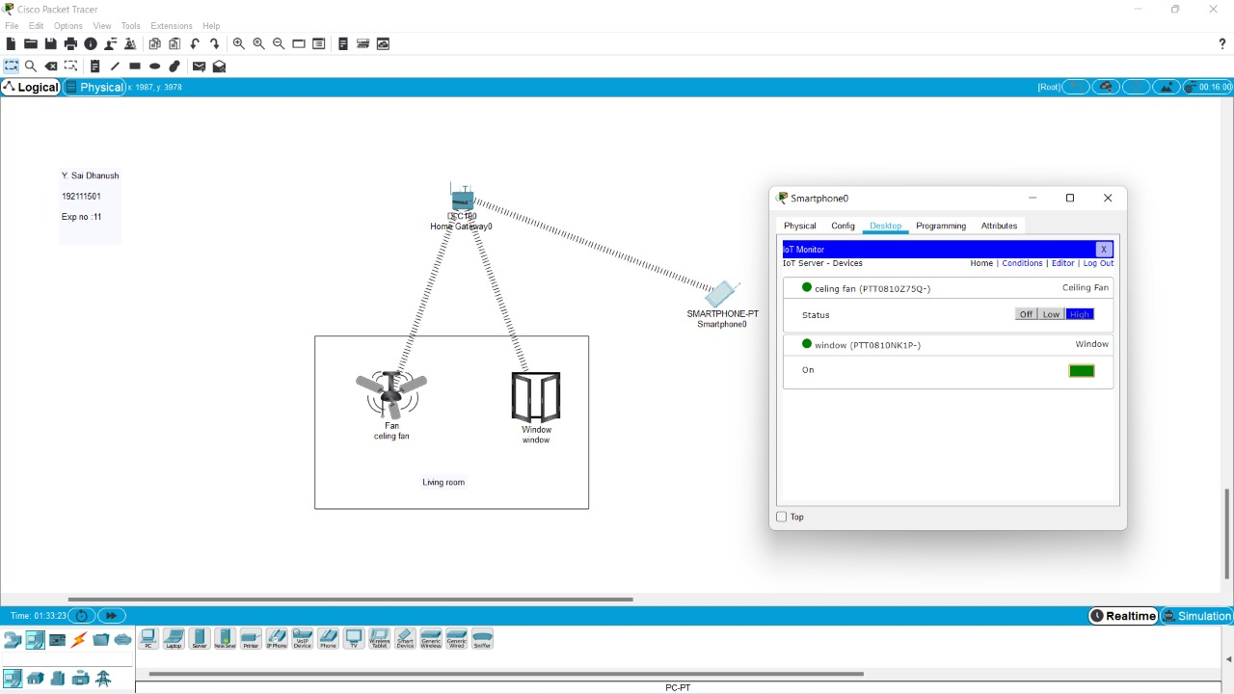

12.SMART GARDEN CISCO PACKER

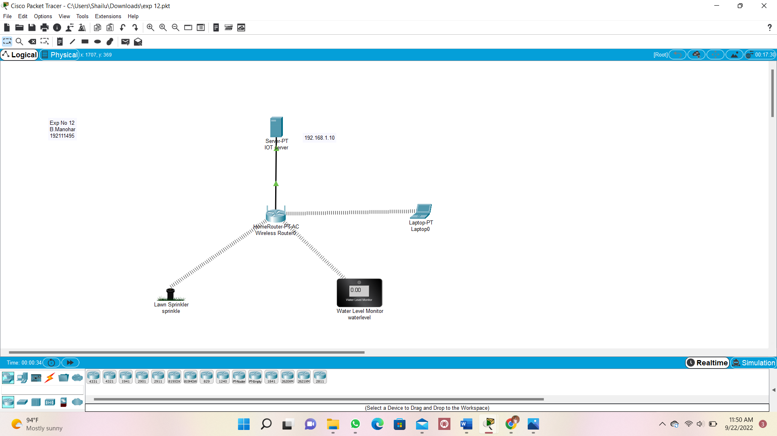

13.IOT DEVICE IN NETWORKING CISCO PACKER

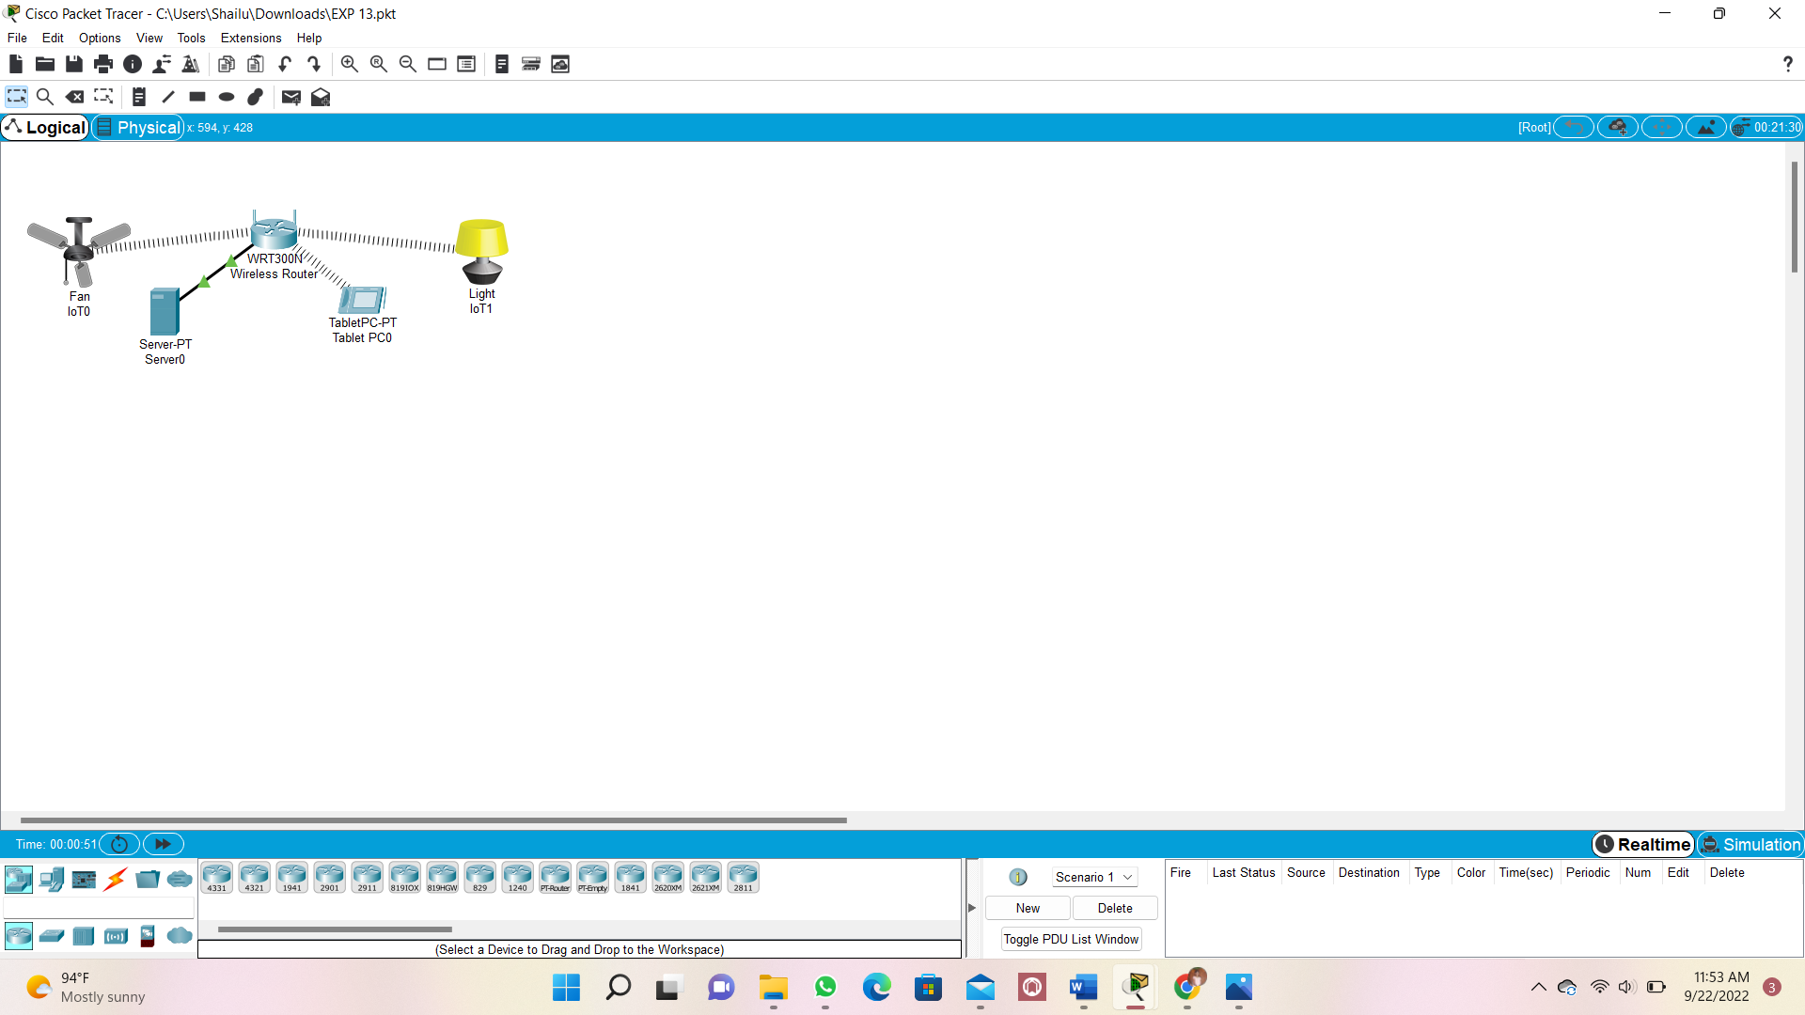

**14.XYZ COMPANY NETWORK DESIGN:**

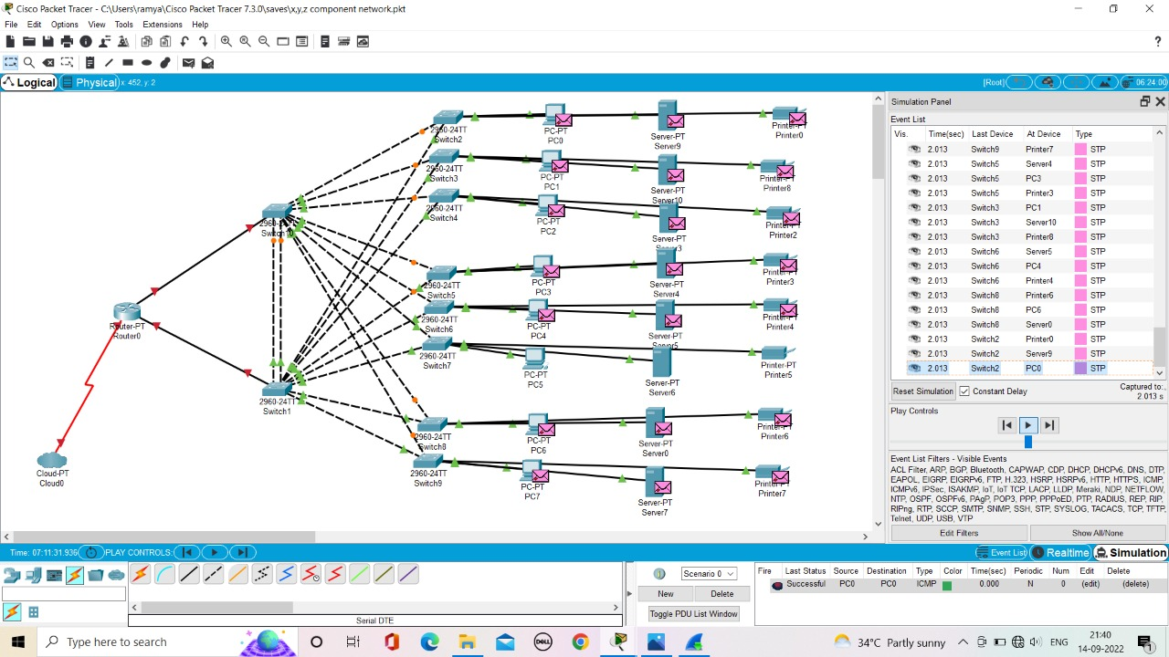

15.COMPUTER LAB

